1. Creating and Renaming Files/Directories
Create a directory named test_dir using mkdir.
Inside test_dir, create an empty file called example.txt.
Rename example.txt to renamed_example.txt using mv
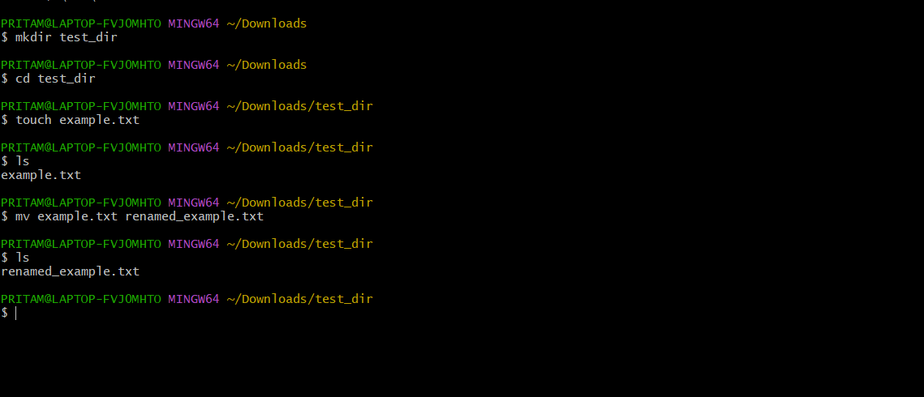
Explanation
- mkdir test_dir → Creates a new directory named test_dir.
- cd test_dir → Changes the current working directory to test_dir.
- touch example.txt → Creates an empty file named example.txt.
- mv example.txt renamed_example.txt → Renames the file example.txt to renamed_example.txt.

2. Viewing File Contents
Use cat to display the contents of /etc/passwd.
Display only the first 5 lines of /etc/passwd using head.
Display only the last 5 lines of /etc/passwd using tail.

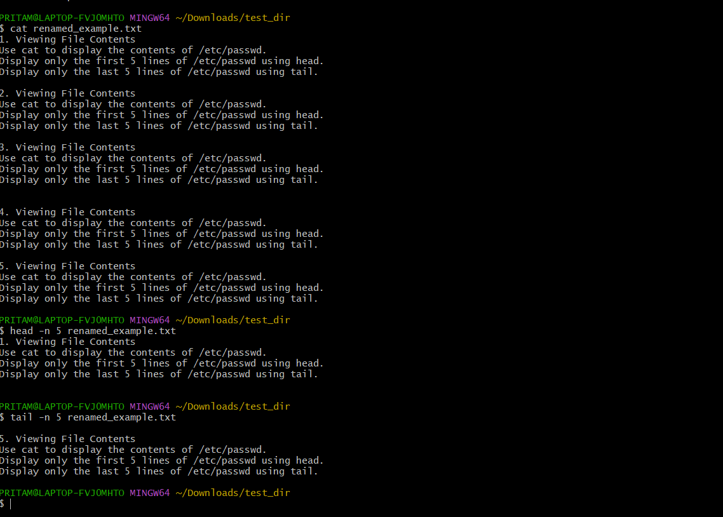
Explanation
- cat /etc/passwd → Displays the entire content of the /etc/passwd file.
- head -n 5 /etc/passwd → Shows only the first 5 lines of the file.
- tail -n 5 /etc/passwd → Shows only the last 5 lines of the file.

3.Searching for Patterns
Use grep to find all lines containing the word "root" in /etc/passwd.
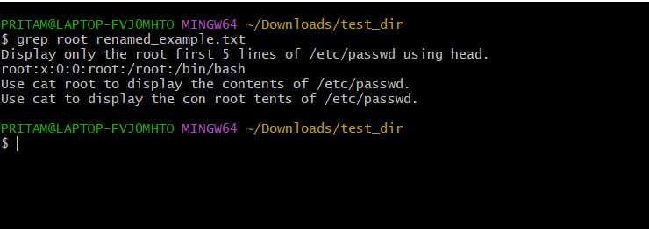
Explanation
- grep → Searches for a specific pattern or word in a file.
- "root" → The word being searched.
- /etc/passwd → The file where the search is performed.

4. Zipping and Unzipping
Compress the test_dir directory into a file named test_dir.zip using zip.
Unzip test_dir.zip into a new directory named unzipped_dir.
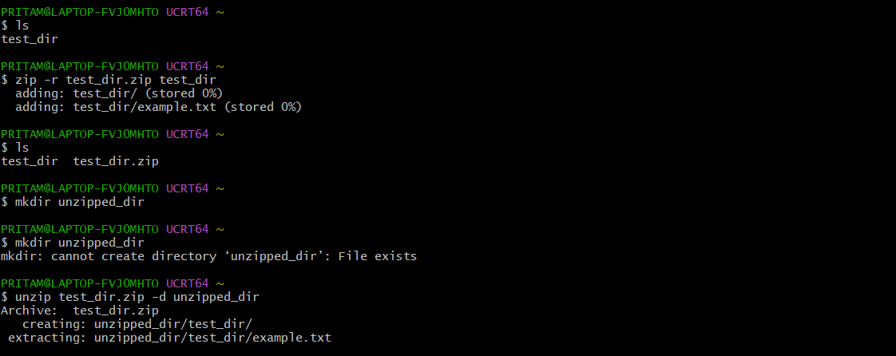
Explanation
- zip -r test_dir.zip test_dir → Compresses the test_dir directory into test_dir.zip.
- mkdir unzipped_dir → Creates a new directory called unzipped_dir.
- unzip test_dir.zip -d unzipped_dir → Extracts the zip file into unzipped_dir.

5. Downloading Files
Use wget to download a file from a URL (e.g., https://example.com/sample.txt).
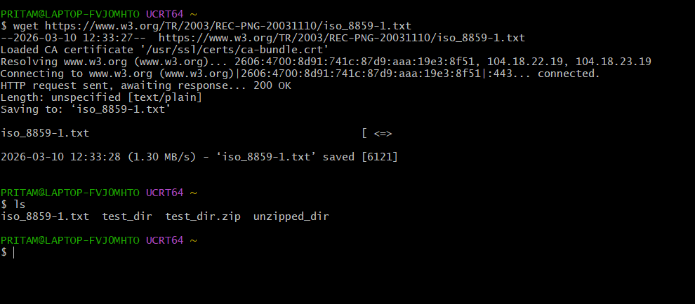
Explanation
- wget → Downloads files from the internet.
- https://www.w3.org/TR/2003/REC-PNG-20031110/iso_8859-1.txt → The URL of the file being downloaded.
6. Changing Permissions
Create a file named secure.txt and change its permissions to read-only for everyone using chmod.
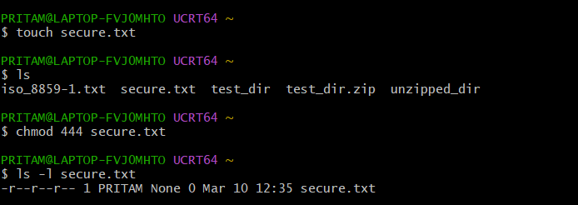

Explanation
- touch secure.txt → Creates an empty file named secure.txt.
- chmod 444 secure.txt → Changes file permissions to read-only for everyone.
Permission 444 means:
- Owner → Read
- Group → Read
- Others → Read
No user can modify or execute the file.

7. Working with Environment Variables
Use export to set a new environment variable called MY_VAR with the value "Hello, Linux!".
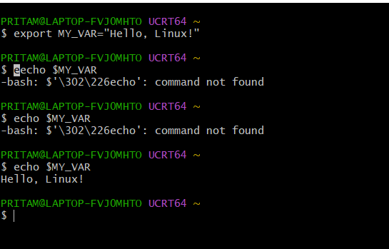

Explanation
- export MY_VAR="Hello, Linux!" → Creates an environment variable named MY_VAR and assigns it the value Hello, Linux!.
- echo $MY_VAR → Displays the value stored in the variable.

Submission Guidelines -: Attach Screenshots or command along with explanation and submit in doc(google doc or microsoft doc) format also attach github repo link

